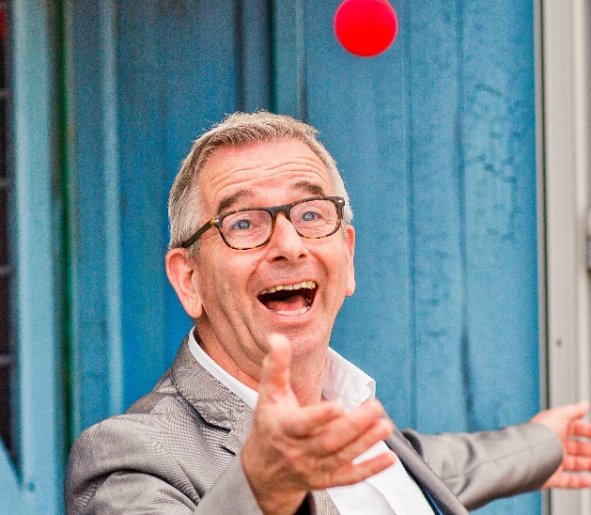 |  |  | Sibe Doosje (father of two children, married with Cornelia Cody) loves to play with people, images, words and concepts en loves to learn (to and from).  Work experience  1990-–1997  Lecturer of psychology  Program for nurses  Prinses Margrietschool, Rotterdam  1990–2022  University lecturer of Clinical Psychology, several coordinating functions, co-founder Teaching Academy Utrecht University, 2022 Maarten van Son prize for Teacher of the year, Chair of Board of Examiners, Chair of Faculty Council  Utrecht University  2010–heden  Director  Humor Lab, Utrecht  Training  1975  Atheneum (high school) diploma, Schoonoord, Zeist: Nederlands, Engels, Frans, Aardrijkskunde, Biologie, Economie I en Economie II  1989  Master’s of Science in Psychology  2010  Doctorate at Utrecht University, Sense of humor: Assessment and health  2011-2022  Faculty of Social and Behavioural Sciences  Several programs and courses on quality of assessment, educational leadership, Socratic dialogue  Activities  2000-2022: Giving presentations  Workshops and presentations about humor and laughter, for care and educational organisations and companies, like Alcmaeon, studentenvereniging SPIN, Julius Research Center, KNMG, Hogeschool Windesheim and Sint Nicolaaslyceum  2000-2022: Popularisation of knowledge on humor and laughter  Contribute to television, radio en press media on humor and laughter, such as Nieuws en Co, Swammerdam, Regionale Televisie Utrecht, Noorderlicht, het Klokhuis, Tros Kompas, Checkpoint, Quest, NRC Next, de Volkskrant  2000-present: Other playful activities  Chairman of the day, master of ceremonies, coach of a girls football team, bariton, organiser of parties, amateur phorographer, cyclist and poet.

Sibe

Doosje

player
Telefoon:
0618989566
E-mailadres:
sibedoosje@gmail.com
Website:

https://sibedoosje.nl
https://humorlab.nl
Adres
Utrecht, Nederland
(Skills: see next page)

Skills
Research skills, proficient in speaking and listening in Dutch, Frisian and English (native speaker), German and French (A2), and Spanish (A1), academic writing in Dutch and English, competent in MS Office, Wordpress, SPSS and AMOS software
